Homework 30/3/’20 – 3/4/’20
Junior Infants:
- ‘Just Phonics’: p.76

- Junior Infants sight (tricky) words: Row 4 (go, see, look, of)

- Blending: Word Box II
rain fun jail bun rail
fog mud fizz ant yet

*Just to remember ai is a double sound ☺

- Core reader 2: ‘On the Farm’
Read one page per day. As the children’s readers are at school I have printed out the first five pages of the book. *Please find attached in the next word document. Please note that books are also available on folensonline.ie.

- ‘Busy at Maths’: p. 33 & 34

Core Reader 2: ‘On the Farm’
Page 1: It is fun on a farm. 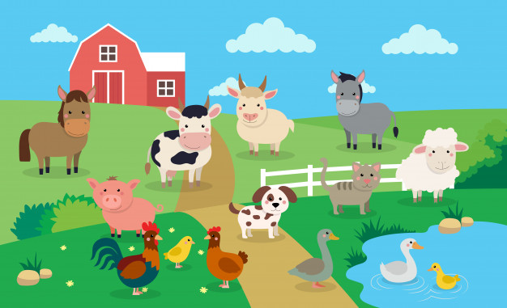
Page 2: Here is Zeb. He is a cat. 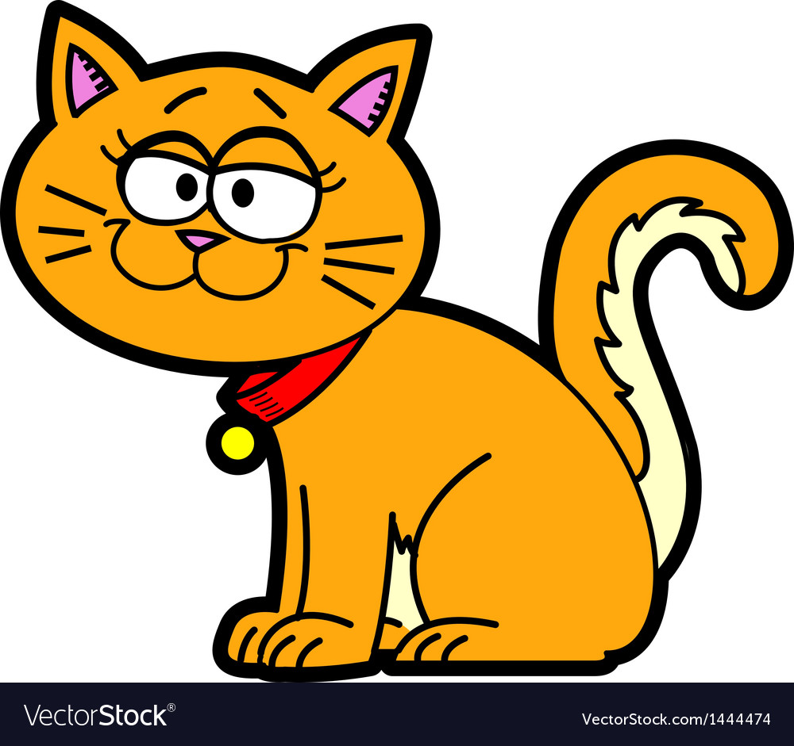
Page 3: Zeb has milk. 
Page 4: Here is Peg. She is a hen. 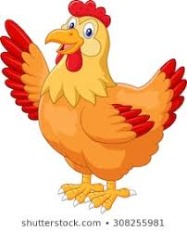
Page 5: Peg has six eggs. 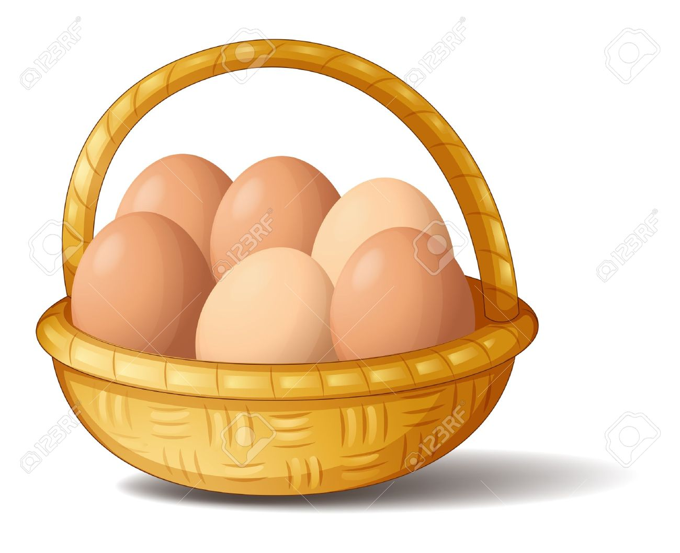

*Reading Tips ☺
Firstly, I would suggest that you teach the new words on each page, for example read the words to your child, ask them to put the words into sentences and practice blending with the children.
Here are the new words for the first five pages: fun, farm, Zeb, milk, Peg, hen, six, eggs.
As you work on each page, please ask children to pick out any sight (tricky) words they recognise.
P.S. I have also included a word document containing some of their Irish rhymes that they have been doing in class this year.
Hope everyone is keeping well!
Míle buíochas,

Áine Galvin

Lámh lámh eile,a haon,a dó
Cos cos eile,a haon a dó
Súil súil eile, a haon a dó
Cluas.cluas eile,a haon a dó.
Ceann ,srón,béal,smig.
Fiacla bána I mo bhéal istigh
GUGALAÍ GUG
Gugalaí Gug,mo chircín dhubh
Suíonn sí síos is beireann sí ubh,
Ubh inné is ubh inniu,
Gugalaí gug mo chircín dhubh
IS MAITH LIOM BAINNE
Is maith liom bainne
Is maith liom ubh
Is maith liom im
Is maith liom subh.
AN FROG AGUS AN GHÉ
Aon,dó ,aon,dó,trí
Frog mór ramhar ina shuí
Trí ,ceathair,ceathair,cúig,sé
Hata beag bídeach ar an ngé.
CUIR ORT DO CHOTA
Cuir ort do chóta
Cuir ort do chóta
Cuir ort do chóta mar tá an lá fliuch.
Bain díot do chóta x2
Bain díot do chóta mar tá an lá tirim

